Architecture Design

High Level Design

1) Introduction

1.1) Purpose

This document will explain the architecture of DEM software.

1.2) Developing environment:

OS: Linux

Framework: QT(QT quick QML).

3D render library: OpenGL.

1.3) Use case description:

1.3.1) Usability & Maintenance

We use design pattern MVC for this project. MVC (Model–view–controller) is a software architectural pattern for implementing user interfaces on computers. It divides a given software application into three interconnected parts, so as to separate internal representations of information from the ways that information is presented to or accepted from the user. In the Model Modules we have File Data Object and I/O Layer. The Controller Modules we have 3D Process, Modules Process and Control View Data (This part going to contact with View Modules, for what you wait to show) all of them for process files DEM, how to move, cut, and zoom and 3D printer. Finally is View Modules. this is only show the data from the Control View Data giver, and it has the UI for user has easy way to contact to the Controller Modules.

What do we have when we have all the best things above? The First about usability, which meant the developer, will know where they are and what they are doing with this situation. The developer can detect where the problems are and what to do first. For example, if we have a problem about zoom DEM images, that meant we know the problem from Zoom Modules and this Modules has a problem from Zoom Controller. The developer read the zoom method and fixes the wrong algorithm. They can easy to make more features without care about other Modules. Finally, it so easy for maintenance, not only for us, it easy for another team, if they are going to reuse our code. It is easy because although it has many modules, and we only have to maintain the module that has problems.

1.3.3) Performance

1.3.4) Design constraints

2) Overall Description

2.1) System architecture

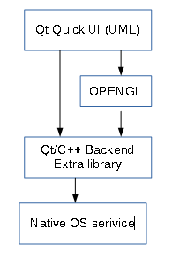

Qt Quick (QML) framework: Build user interface. Handling binding data, view animation.

OPENGL: Provide 3D process library.

Qt/C++: Provide database, file access api.

Extra library: library for processing dem file.

2.2) Software block diagram:

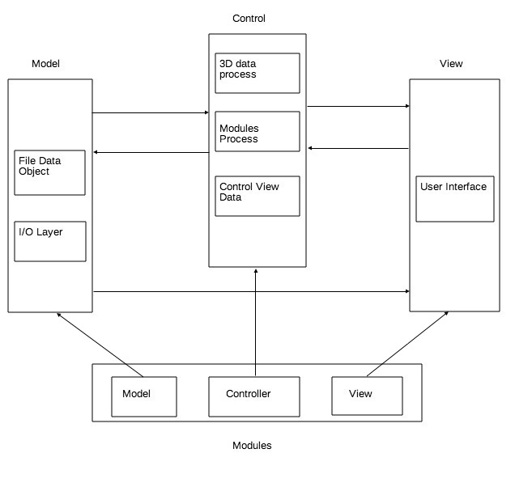

Model: Handle File In/Out include read Dem file or Export. Model also holding Dem file Object

Controller: Control data flow, processing action request from view

View: Show user interface

Modules: a component include Model, Controller & View as part of program such as file module or zoom module

2.4) Data flow

2.4.1) Open DEM file button

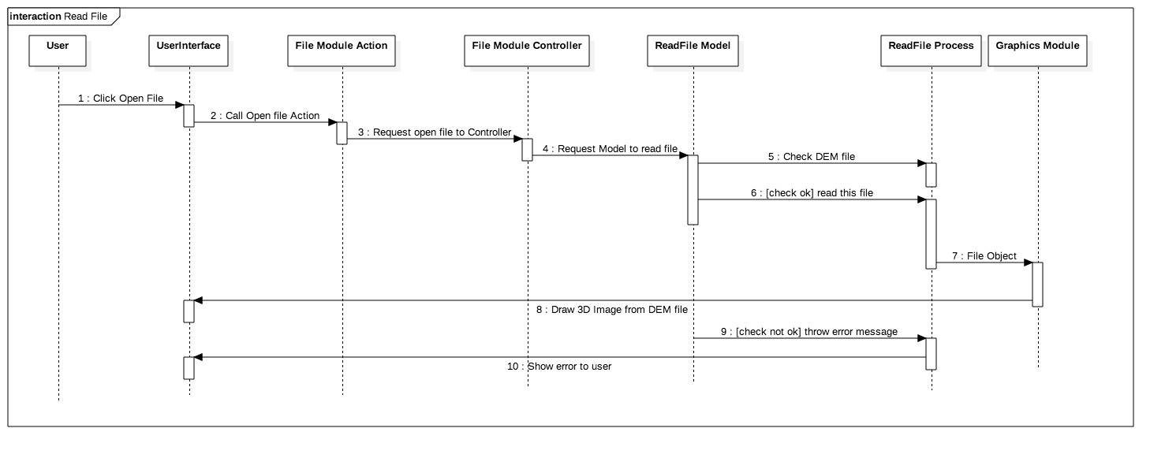

2.4.2) Zoom

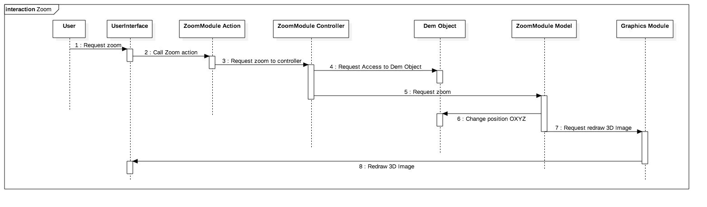

2.5) Class diagram

The main idea here is separate the program into multiple modules, each module just take care one task. For example, file module will handle read Dem file or export to OBJ/STL format. To do that, we need to build a basic system with ability to install modules. The following class diagram provide a way to to that.

2.5.1) Controller

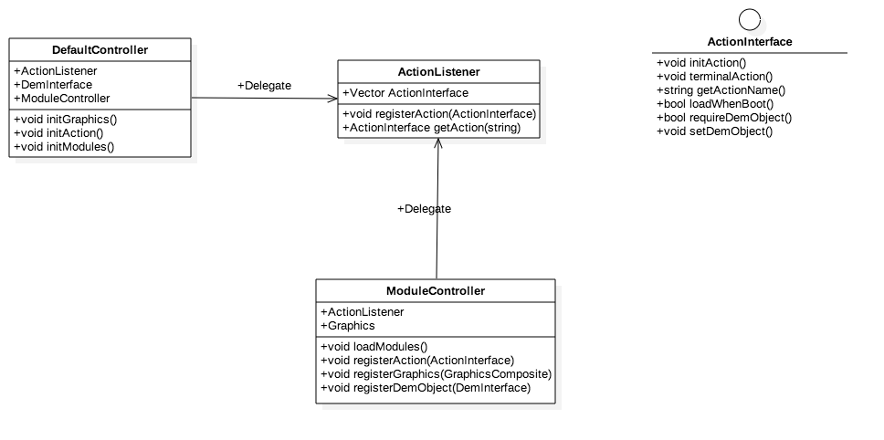

Action listener is the heart of the program. It provides a way to user interaction with program. ActionListener will collect actions registered from modules & can be called from graphic viewer if needed. ActionListener also allow modules to register to access data from model.

2.5.2) Base Element of Dem file

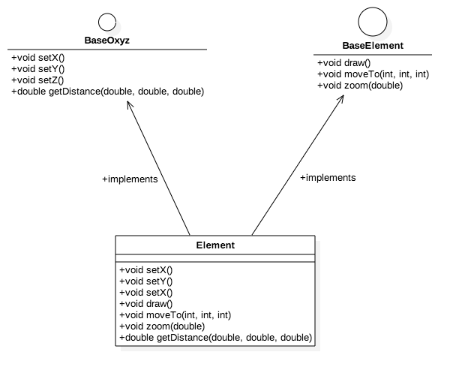

This is the basic element to represent element in Dem file.

2.5.3) Read Dem file

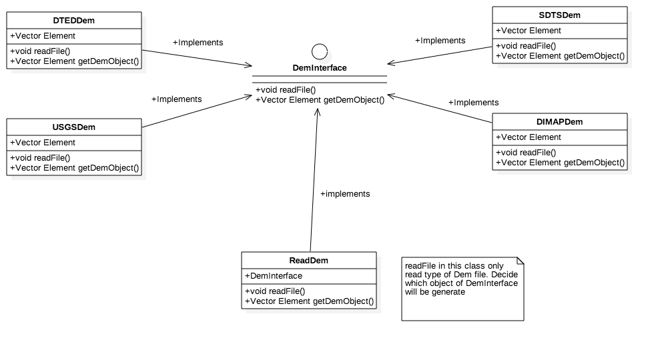

We have 4 type of Dem file. So, we need 4 type of class to read those types. But all of those types will have same interface Dem Interface.

2.5.4) Graphics

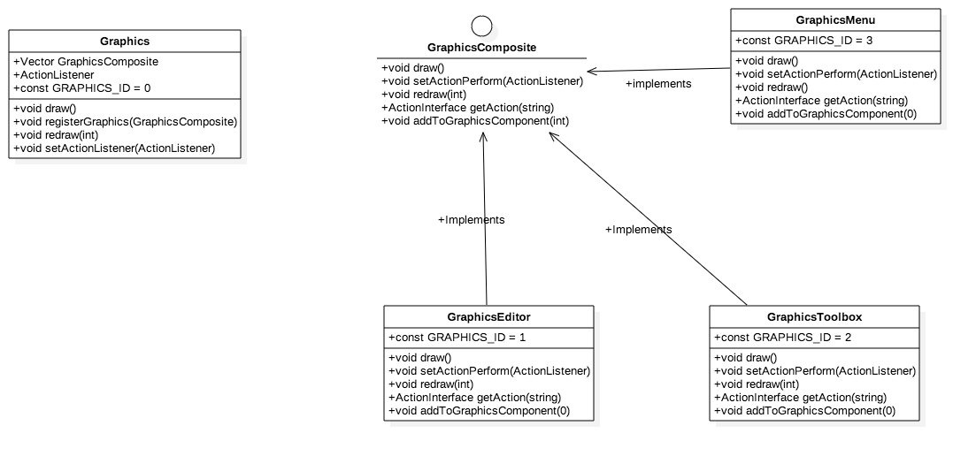

In the User Interface, we have 3 basic graphics component includes:

* GraphicsMenu: Menu in the top of program. Included a direct way to access functions of program, such as file, view, etc.
* GraphicsToolbox: A control panel of program.
* GraphicsEditor: An area where 3D Image will be paint.

2.5.5) Modules

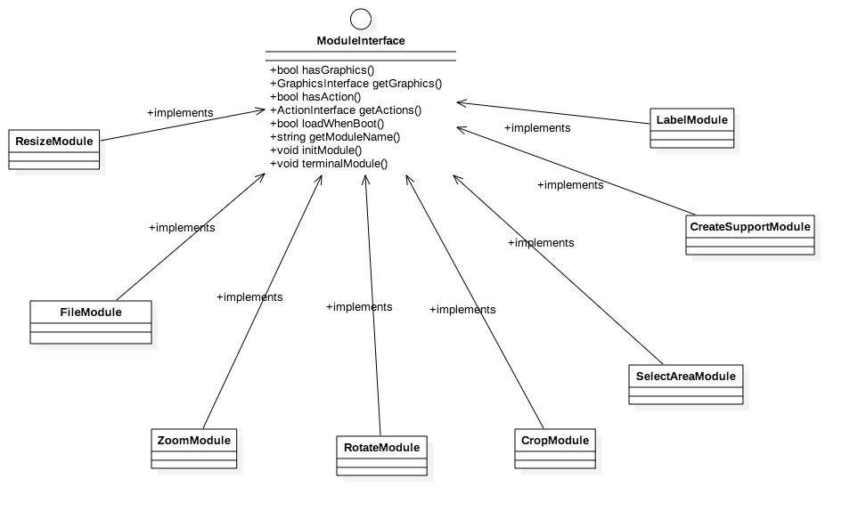

Every module in this program must implements this interface, which require a basic needed to register a module.